Cross-cultural discovery of the Louvre
The present questionnaire was delivered in a French/English version during the Training Course.
*The aim of this visit is to allow you to discover the World's biggest museum through a series of works related to the issue raised by the seminar. Some of these masterpieces perform different acts and topics relevant to the "three cultures"… It's up to you now to find them out and to answer to the following questions.

Photo | Location | Question? | Answer
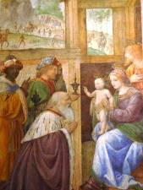 | Italian Paintings | 1. What is the role of the three main characters? To which religion do they refer to? | The Three Wise Men announcing Jesus’ birth
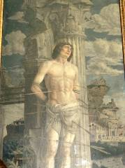 | Grande Galerie | 2. What is a martyr? What is the name of the one on this painting? To which religion does he refer to? | It is the symbol of the first Christians who died for their faith. The painting shows Saint Sebastian
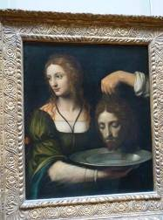 | Idem | 3. Do you know the story behind this painting? Can you tell it? Do you know where the corpse is buried? | Salomé is receiving the head of Saint Jean Baptist. The corpse is buried in Damascus.
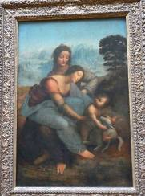 | Idem | 4. What is particular about this painting? | This painting is unfinished;
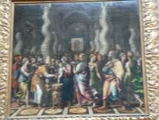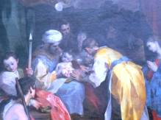 | Idem | 5. Which ceremony is celebrated according to the paintings? What are the religions concerned? | The celebration concerns circumcision. It is mostly known and practised for Islam and Judaism.

Photo | Location | Question? | Answer
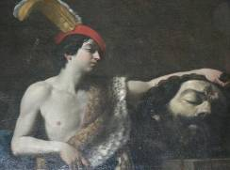 | Floor 1  Room 8 | 6. Which story is told through this painting?  What is its main symbol? | The fight between David and Goliath is the metaphor for the weak taking over the strong thanks to faith.
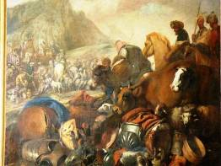 | Floor 1  Room 13 | 7. Who is the character, capital to the three religions, represented here | This is Abraham, the Patriarch of the Hebrews and first prophet for monotheism.
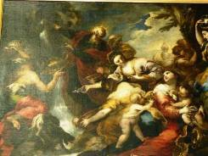 | Floor 1  Room 13 | 8. Who spurts water out of the rocks? How is he regarded in each of the three religions? | It is Moses…
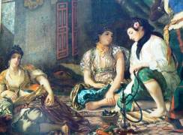 | Paintings  Room 77 | 9. Where do you think the scene is taking place? What is particular about this painting? | The painting is called ’’Algiers ladies’’ .. yet, the faces are European-like .
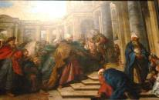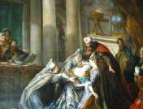 | Sully  Room 74 | 10. The two paintings draw a very famous episode in one of the three religions. What is it about? | The episode concerns Amman and Murdoch.

Photo | Location | Question? | Answer
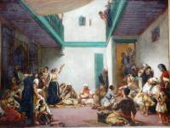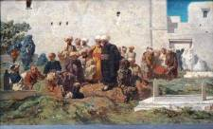 | Floor 1  Paintings | 11. The two paintings offer views of the everyday life. Do you recognize them? | It is a Jewish wedding and a Moorish funeral.
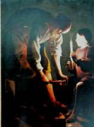 | Floor 1  Paintings | 12. Who is the main character here?  Which place does he hold in Religion? | It is Joseph the prophet OR Joseph the husband of Mary.
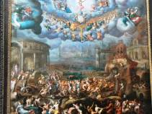 | Richelieu  Room9 | 13. Here is a very important event for different religions? What is it exactly? | The judgment day.
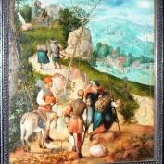 | Floor 2  Room 9 | 14. Is there any link between the painting and some religious feasts? Which one? | The sacrifice Day is celebrated in Islam and Judaism.
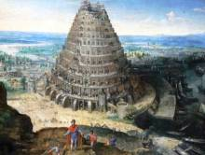 | Floor 2  Room 13 | 15. What is the main symbol out of this painting? | The Babel Tower is the metaphor for the difficulty to communicate between people.

Photo | Location | Question? | Answer
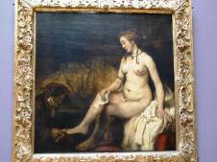 | Rembrandt | 16. Look very carefully at the painting! Do you think love and religion go hand in hand? | Bethsabee having her bath (open question)
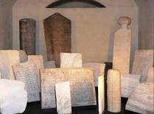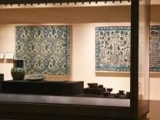 | Islamic arts | 17. You are reaching the last step of this journey with the Islamic art department. What is its main specificity? | Open question!

Recommendations

- Work in team
- The questionnaire is individual, but some questions may accept a collective answer
- Follow the journey's plan
- Feel free to observe, appreciate but don't touch the works
- Read the boards and plates offered in the rooms available in different languages
Join the other groups at the meeting point at the end of your journey. Be on time for the final debriefing

